Coils & Curls: A Mathematical Tapestry of Black Hair

Renee Jordan & Kofi Oduro (Illestpreacha)

Black HairStory, Black History

Black hair (Afro texture hair), not the color of hair comes in an entire range of patterns before it is even cut, styled, braids, chemically colored or chemically treated. It is an expression of the shape of the hair follicle. Hair strands are made up of protein called Keratin, that in turn is made up of amino acids and depending on how these amino acids bond, the bonds increase the chances that the hair will bend (Gaines et Al, 2023). Black hair can emerge from the follicle in many ways, it can be wavy, coiled, zig zagged, tightly packed, loosely packed, extremely dense, it can be coarse, it can be thin or somewhere in between. There are many pattern combinations that can be used to describe black hair. In this paper there will be a discussion of black hair from its root its history, to its views in society to style and expression. Within each step a pattern emerges.

Through poetic ethnography, an exploration of what it is to experience and live through this hair experience can be witnessed by others. As hair is not something that just disappears but has its own stories to told and through poems, it can tell a bit (Maynard & Cahmman, 2010).

Below is a poetic ethnography of the patterns that arise from the hair within the community, through the eyes of a community member as they voyage thinking of the BlackHairStory.

A BlackHairStory

Black Hair is complex
It cannot be charted
3c,4b,4c,
Zig zags, coils, s-shapes
can all exist on the same crown

Black Hair is complex
it can stand up,
Be laid down,
Cut, curl, locked, braided
It is a form of expression
With a deep historical background
Black Hair is complex,
off the chart
It has texture, density, porosity, elasticity, hydration.
It behaves differently responding to the situation.
Black hair is complex,
It tells our history…
It was once a display of status or state
If one was single or had a mate,
Was off to war
And to whom you belong
Black hair is complex,
A sign of conformity or a beacon of resistance.
Prepped with special tools
Used as tool to preserve our existence.
Black hair is many things,
Deeply rooted in or existence,
Some may think it is just hair
But it is more than hair,
It’s part of our HairStory, our History.

1. HOW MUCH COILAGE IS IN YOUR HAIR?

In the 1990’s, Andre Walker who was Oprah Winfrey’s hairdresser created a chart that would still be in used by many till this day as a source of identifying their strands and determining how to treat them. Walkers chart comes with controversy as some view it as an oversimplification of the complexity of black hair (Mello Hair Solution, 2020). With some even harboring a great disdain for it (GMMoira, 2023)

Walkers chart Introduced a letter number system, ranging from strait to very coily.
Leaving out many of the attributes that categorize black hair. Though the qualitative basis of this chart, it left many frustrated with their hair styling and treatment as it was taking it only one dimension of hair. Black hair has indeed has some of the shapes as express by the chart but many of the shapes can exist on the same head. Therefore, if one was selecting a process or line of treatment based on this factor, it is difficult to witness the various patterns and geometric entities, scalp may contain. (Gaines et al, 2023)

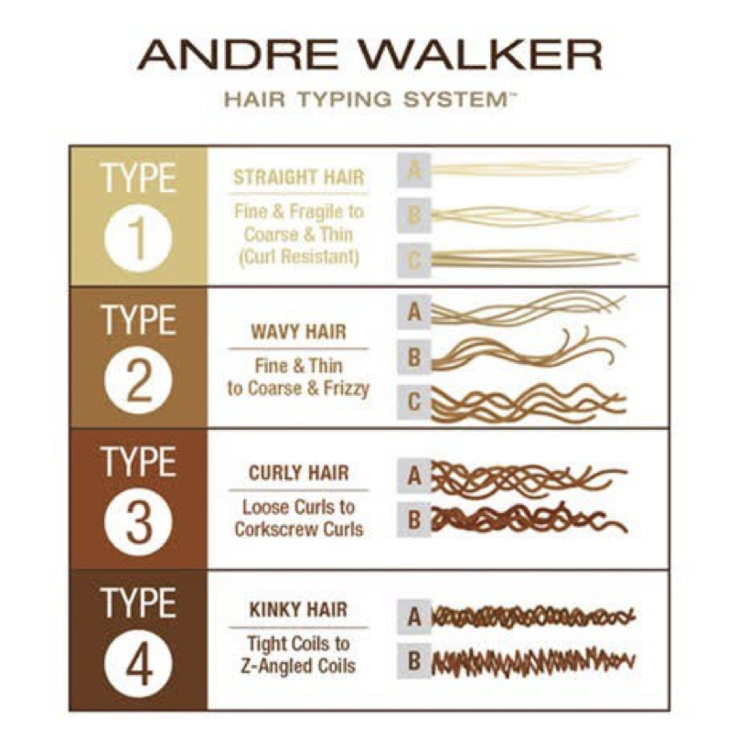
Figure 1.0 Andre Walkers Haire Typing System
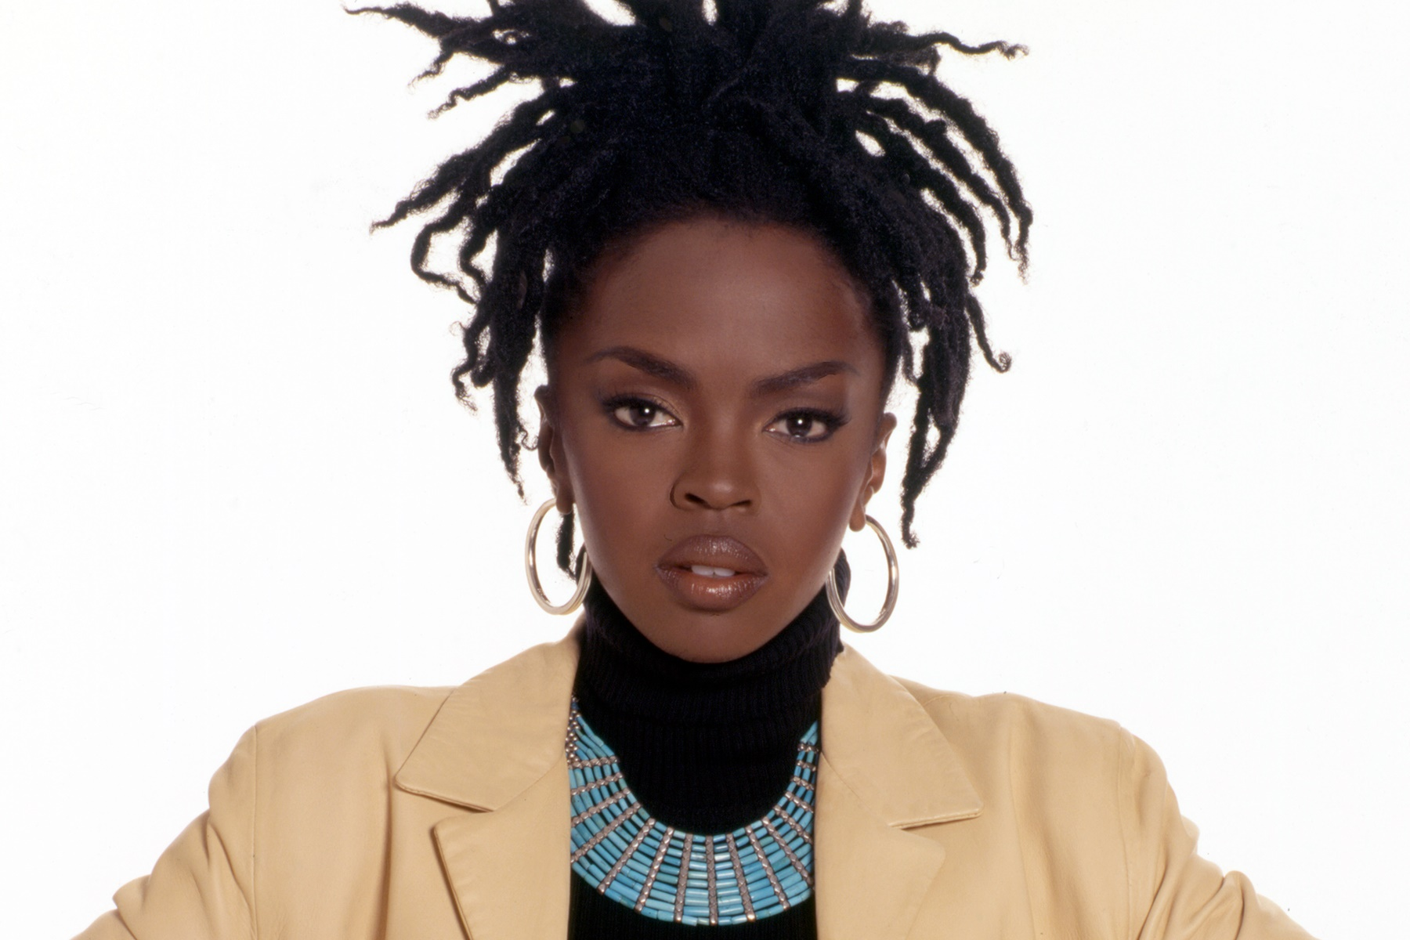
FIgure 2.0 - Picture of Lauryn Hill

Black hair can be coilly in some areas, loose in its more porous area near the crown and sometimes its loosest curl can be found at the name. Very seldom will one uniform pattern exist throughout one person's head of hair. As seen in the picture above. Through visual research and analyzing patterns, it can be noted that when speaking of black hair there are several design possibilities that can be noted. Visual research can show results that may be taken for granted such as hair categories (O’Grady, 2017)

This can be classified by its curl shape, its surface texture, porosity, its density and strand thickness, and its ability to reflect light, all which can be used to recommend products for proper hair care and styling which becomes an equation that differs between people and styles.

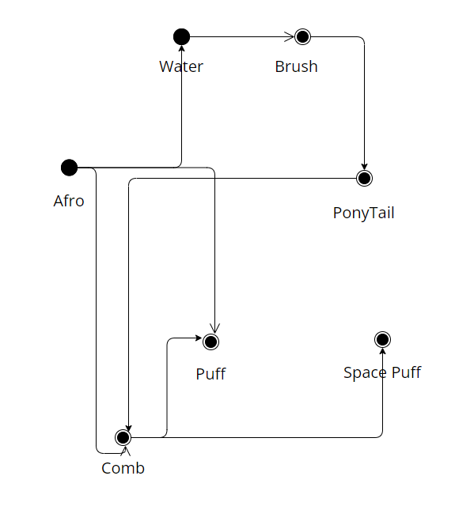
Figure 3. 0 – Hair Styling Graph with Hairstyles and Tools as Vertices

As seen in Figure 3.0, The afro can be considered the base foundation of many hair styles. As it is easy to move up or down between cuts and styling. For some hairstyles, there is a need of a brush, while for others there is a need for water. This graph is just a representation of a couple of nodes, so it does not consider how items such as hair gel, conditioner and relaxers can affect the strands of the hair.

From the equations mentioned to the patterns of the chart from Andre or the new one from Gaines and her team, there is a sense of ethnomathematics that follows the way black hair is seen and used. Through ethnomathematics, we can see how the expression of the hair are not only rooted in creativity or cultural references but also see the math that is within. (Gerdes, 1994). As all has a starting point and that is the root.

2.0 HAIR FROM THE ROOT

Hair emerges from the scalp and what is seen on the outside starts from the other side of our scalp. The hair follicle is located in the first and second layer of the skin (the epidermis and dermis) and sometimes a third later of subcutaneous tissue. The hair follicle is a cylindrical tube structure that contain hair (Cleveland Clinic, 2022)

It is the shape of this follicle that dictates how the hair on the other side of the scalp will express itself. Hair grows from the root meaning that any new growth will retain the original pattern despite any chemical treatments that are done above the scalp. This is why the Gaines and her team, decided on trying a quantitively approach as the geometric structures can be used to engage in which type of personal products may be used on certain hairs (Gaines et al, 2023)

The expression of the hair above the surface as seen in the graphic below and in the second image an enlarged picture of afro hair (black hair) follicles (Reyes, 2021).
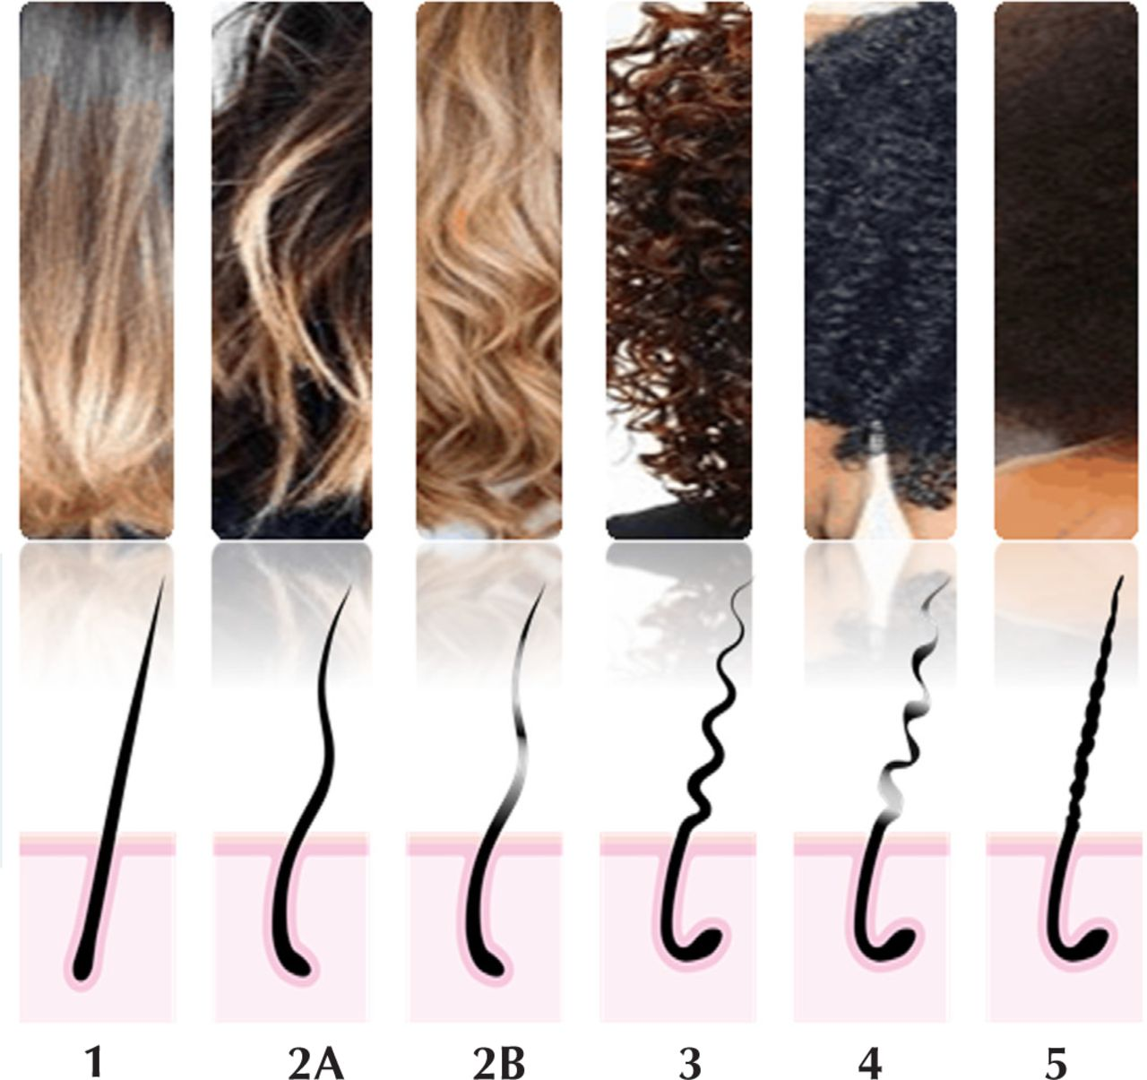
Table 1.1 Some curl types and approximative follicles

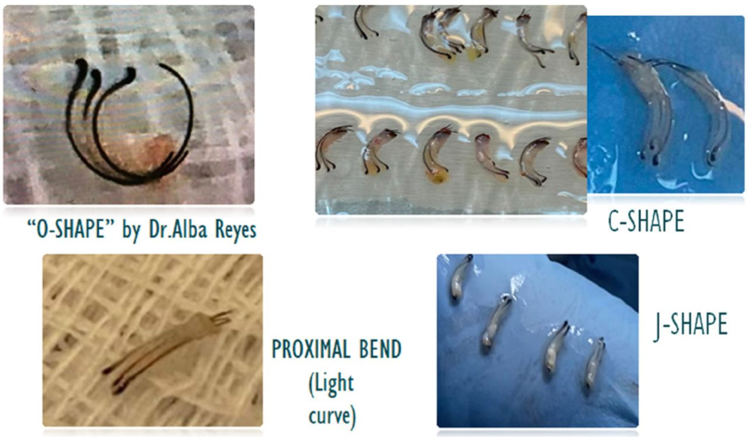
Table 1.2 Different types of hair follicles

The internal curvature of the hair follicle is typically an extension of what we observe externally.

3.0 HAIR THE STRAND

Which Brings us from the roots to the strands. Where beauty and the expectations are set.

But as Kelly Rowland said in her song:

My, my hair, my, my
My hair, my crown (you better)
It don't matter how I wear it (wear it)
It's beautiful in every color (color)
Long, short, straight or curly (curly)
I love what I see in the mirror, yeah-yeah (yeah)
There's no other way I'd rather be (yeah)
Confidence is all I see (yeah)
When and whoever I please
Say it loud - (Rowland , 0:08-0:31)

The crown as referred to by Rowland is a combination of biochemical patterns that form a style as

“Human hair keratin is made up of 14 percent sulfur-containing amino acids (cysteine and cystine”>. It is from these amino acids that many of the properties of hair are developed, particularly curl. When two strands of keratin are adjacent to one another, the –SH bonds for nearby cystine groups can be oxidized to form a disulfide (S-S”> bond between the two strands. This is a chemical crosslink that ties the adjacent keratin strands together. A high proportion of disulfide bonds twist the hair strand into a helical pattern. Adjacent hair strands tend to assume the same pattern, and then cluster together into multi-helical structures that form curls. In this manner, the nanoscopic structure is repeated at the macroscopic level. Nature loves patterns.” - (Mckay, 2012)

As well as

“A helix is a ribbon-like coil that occupies three-dimensions and is governed by specific trigonometric equations used to describe the length of revolutions and the pitch angle” -

X (t”> = r cos t
Y(t”> = r sin t
Z = ct
Where t = [0,2π], c = constant, r = radius, and 2πc = vertical separation of the loops. (Mckay, 2012)

4.0 HAIR THE STYLE

The basis of hair styling in the African, Afro American, Afro Caribbean ie black hair begins at the washing step. Water is essential to keeping hair in its best condition and the longer we can retain moisture within a hair strand the healthier its expression will be. To harness the power of water within the hair strand, start with shampooing the opening the hair cuticle and giving it the ability to accept water, conditioner to seal in that moisture and the styler to make sure this moisture is retained until the hair is cleansed again.

Pattern to maintain healthy hair (generally)

Cleanse (shampoo) + Condition (conditioner) + Style (heat protectant, gel, or mousse to retain moisture)

This brings us to the next pattern in black hair the styling that uses various combinations of tools or products many black hair styles can be achieved.

These tools include several types of combs, detangling brushes, afro pics, clips, crochet hooks, and pins.

Heat can be used to temporarily change the bonding arrangement of black hair. Altering its natural pattern until moisture alters it back to its original state. Heat can be used to straighten black hair directly hot comb, flat iron or indirectly bonnet hairdryer or blowdryer. Heat can also be use to set curly styles.

4.1 HAIR THE STYLE BASICS

Black hair can be styled in a multitude of ways from a few basic methods. The following includes a few of these basic styling techniques. That utilizes smaller patterns to create larger ones. Due to the nature of natural afro textured hair, it can be easily manipulated into these basic styles with lasting hold with truly little product.

The Simplest the two-strand twist, of which a 3-strand twist variation can also be made. Then the next basic style is a braid, utilizing three strands. The flatwise, cornrow, and French braids are derivatives of those basics. If a number can be attributed to each strand.

The twist
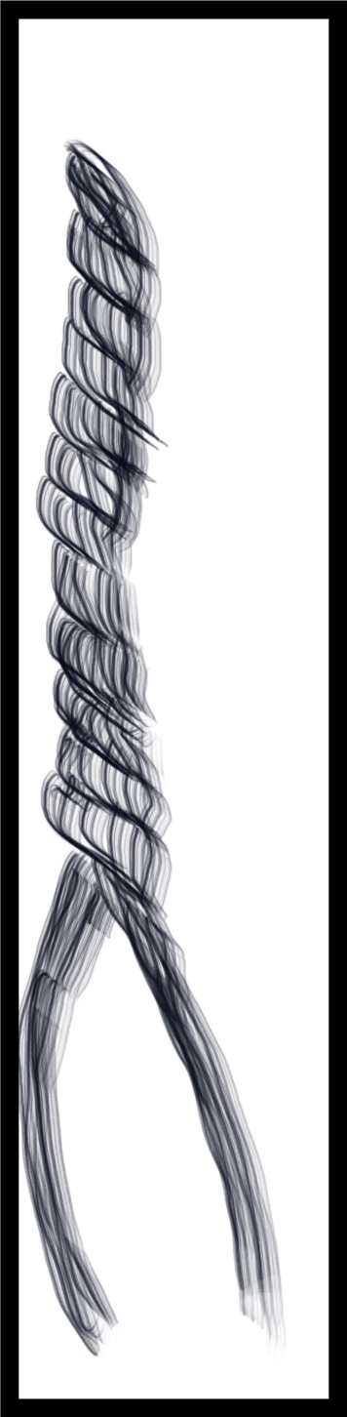
The following pattern will produce the result of a twist where one strand is strand one the other is strand 2.
1 2
2 1
1 2
2 1
1 2
2 1
Figure 4.1 A two-stranded twist
The twist involves lapping the hair one over the other and so each stand would be trading
places.

The Braid
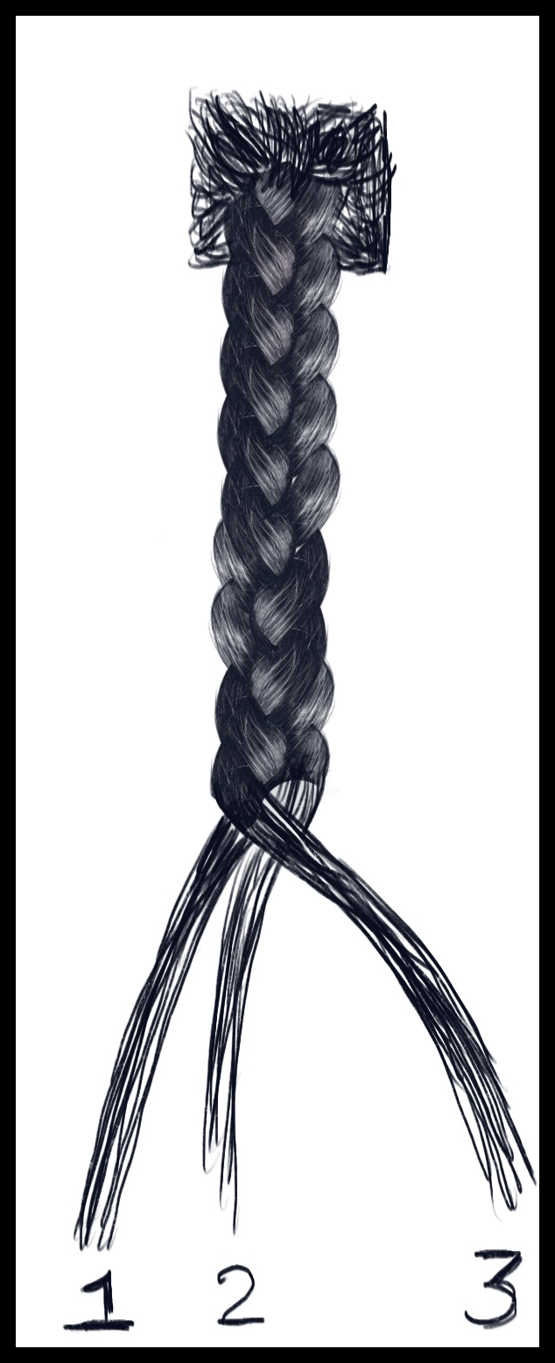
The Braid pattern emerging from a parted section of hair divided into three strands. The strands are moved through the following pattern to build the braid.
1 2 3
1 3 2
3 1 2
3 2 1
2 3 1
2 1 3
1 2 3
(Repeat from the beginning)
Figure 4.2 A single braid made with 3 strands of repeated pattern.
The Flat Twist
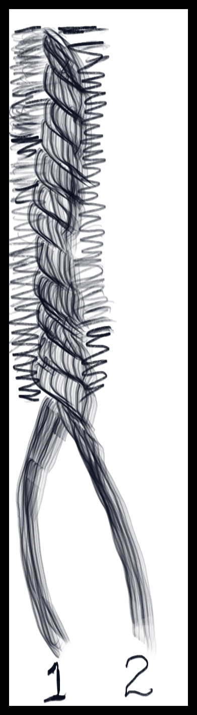
The Flat twist involves the same technique as the twist, but the hair is twisted close to the scalp and more hair is incorporated from the scalp as we travel down the part.
1 2
2 1
1 2
2 1
1 2
2 1
1 2
2 1
Figure 4.3 A Flat twist

The Cornrow
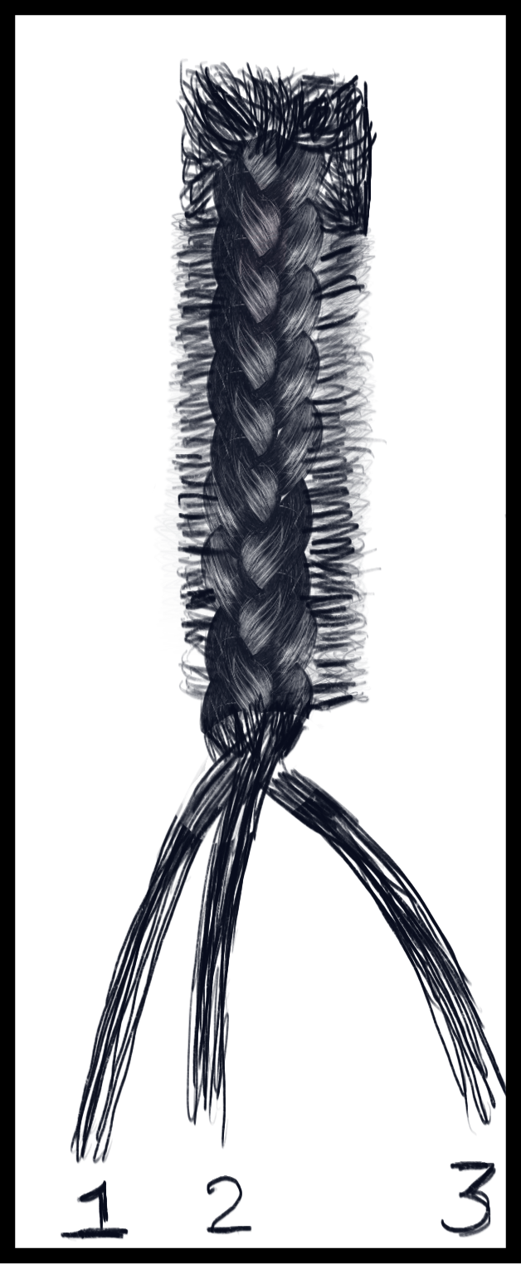
Hairs are maneuvered in a underhanded technique. During which the outer hairs are alternately brought to take the centre place. The outer hairs are passed underneath the centre hair to take its position. So if the numbers 1,2,3 always represent the same hairs the pattern would be.
1 2 3
1 3 2
3 1 2
3 2 1
2 3 1
2 1 3
1 2 3
(Repeat from the beginning)
Figure 4.4 A section of hair that is cornrow

The French Braid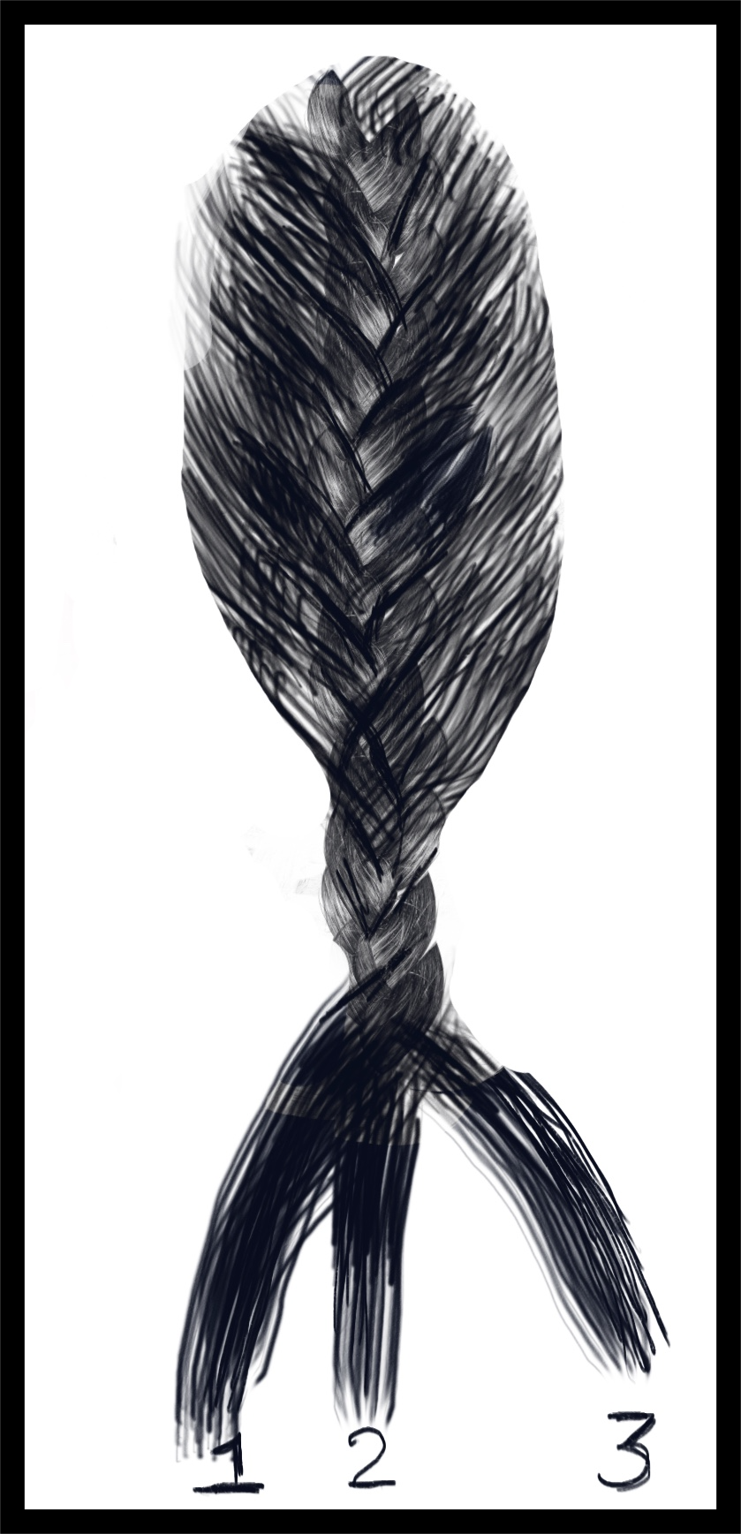
The French Braid- An inversion of the cornrow, hairs are maneuvered in an overhanded technique. During which the outer hairs are alternately brought to take the center place. So if the numbers 1,2,3 always represent the same hairs the pattern would be. Always passing the hair from the outside over top the center hair. When maneuvering the strand from the sides to the centre more hair is picked up along side to gradually incorporate all the hair on the head.
This Braid follows the following loop
1 2 3
1 3 2
3 1 2
3 2 1
2 3 1
2 1 3
1 2 3
Figure 4.5 The French braid on a full head of hair.

4.1.1 Glossary of Other Hair Patterns

Crochet braids: Quickly achieve the look of single braids quickly. With the use of a crochet hook. To loop hair in already cane rowed hair. The preset hair could be locked, braided, curled, bohemian braided is added to the corn row using a looping technique.

Knotless braids (Feed in braids): Hair is added inserted into the braid to extend the braid every at the same point of insertion in the braiding pattern as shown with the basic braid. For example, whenever strand one returns to the first position in the lineup.

Original braids: Traditional extension techniques involved adding the hair from the scalp level by creating somewhat of a knotted pattern to secure the synthetic hair to natural hair.

Locks: This style of hairstyling can be started in several ways palm rolled, finger or combed coils, twist braids or free formed. Each ones of these styles stemming from styling basics. Hair is washed and parted for most of the starter methods. Once the starting position has been set. The hair can is left in this style to bud and mature into its form. Natural curly hair will stay close together and eventually as the term implies lock.

Weaving: The addition of hair in bundles on top of one's natural hair to offer different hair styling options utilizes various patterns as a base to conceal one's hair beneath. Some patterns allow for a more natural look, styling, and parting options and protecting one's natural hair beneath it. Hair bundles are then sown to the braided hair.

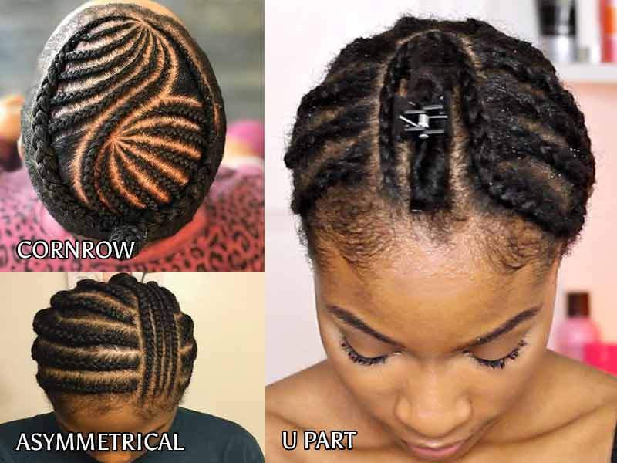
Figure 4.6 Base patterns for weaving.

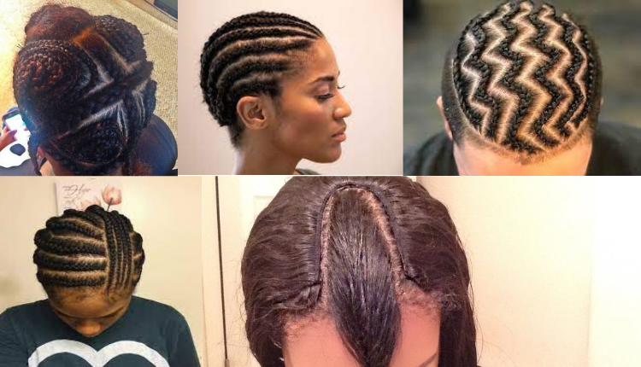
Figure 4.7 Base Pattern for weaving.

4.2 BRAIDED HAIR PATTERNS

The scalp is the canvas for braids and due to the structure of braids filling up a certain amount of space on the scalp, it tends to have a tessellation/tiling. As Braids do not cross and the bases do not overlap, there are several types of tessellations that can be produced (Gilmer, 1998)

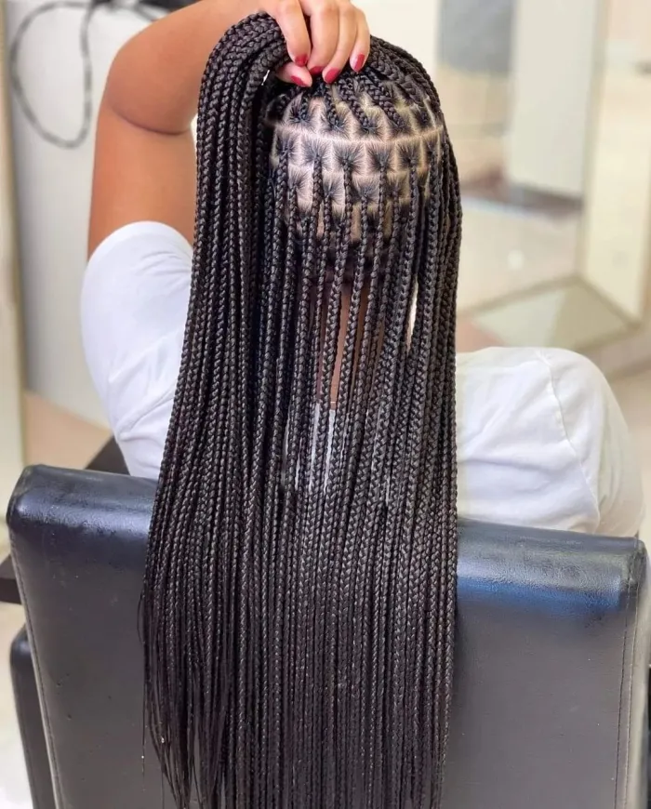
Figure 4.8 knotless-braids a hair expression of the square tessellation (Courtesy of https://www.hadviser.com/knotless-braids/27/)

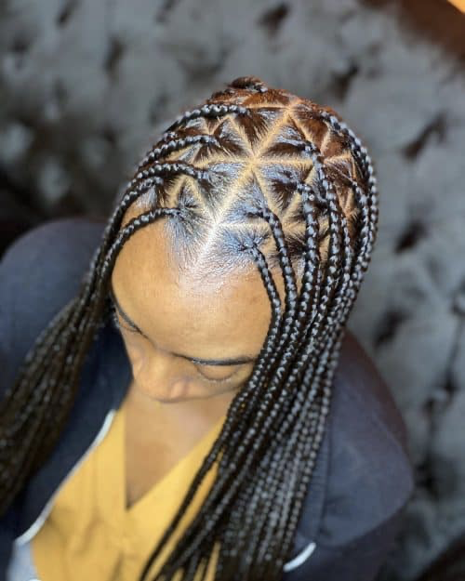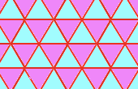
Figure 4.9 knotless-braids a hair expression of the triangle tessellation
(Courtesy of https://www.latest-hairstyles.com/black/triangle-box-braids.html#19

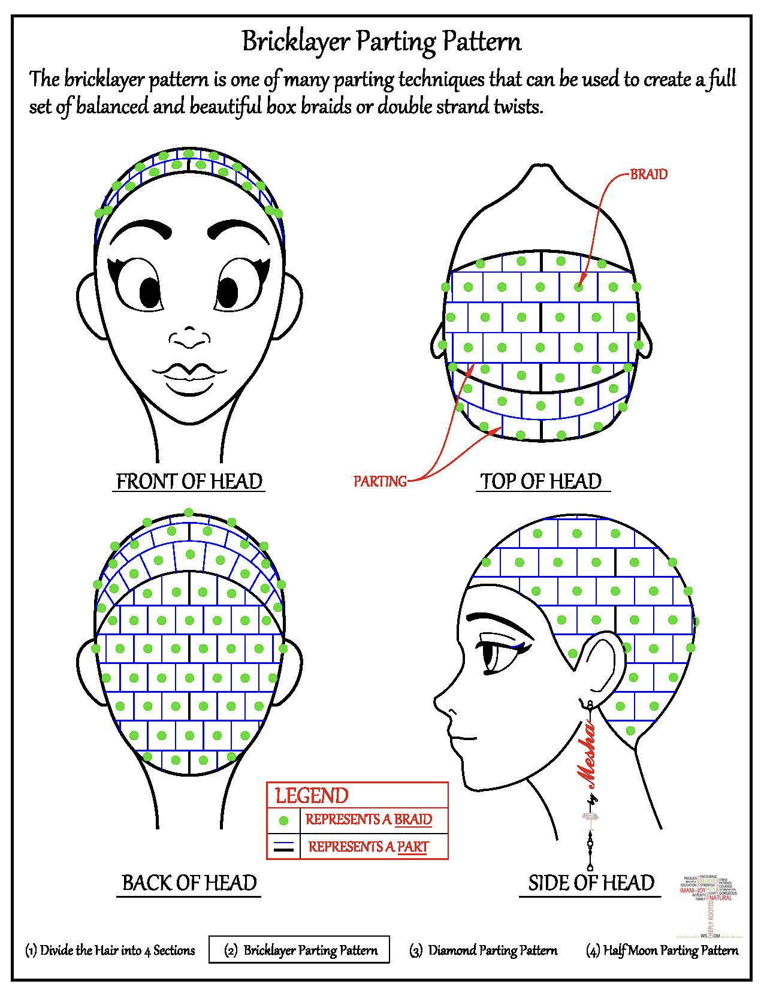
Figure 4.10 The square tessellation when translated on to a head follows the brick pattern as demonstrated above (Courtesy : https://ijnatural.files.wordpress.com/2015/05/bricklayer-parting.jpg)

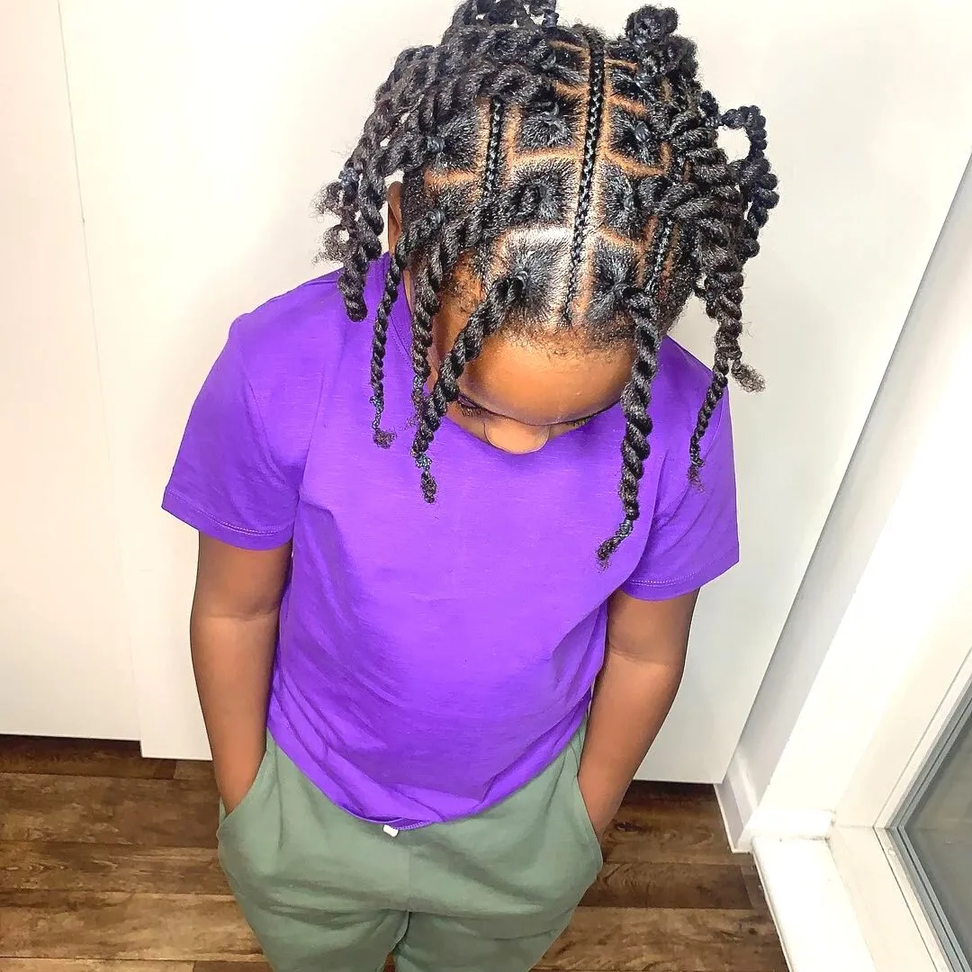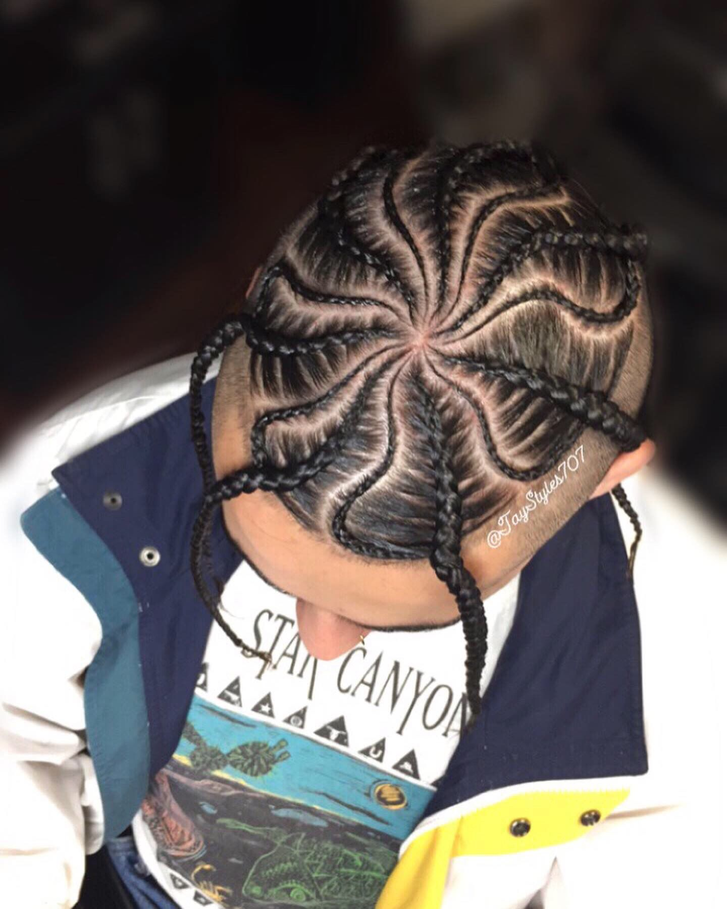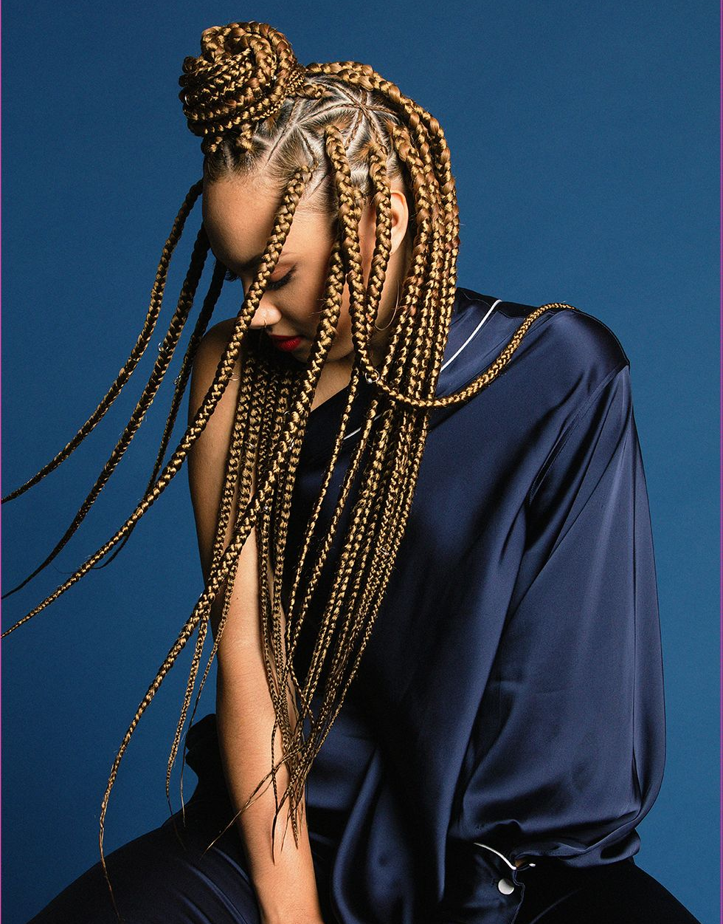
Figure 4.11 Braided Tesselation
(https://www.cosmopolitan.com/style-beauty/beauty/a18581562/triangular-box-braids/)

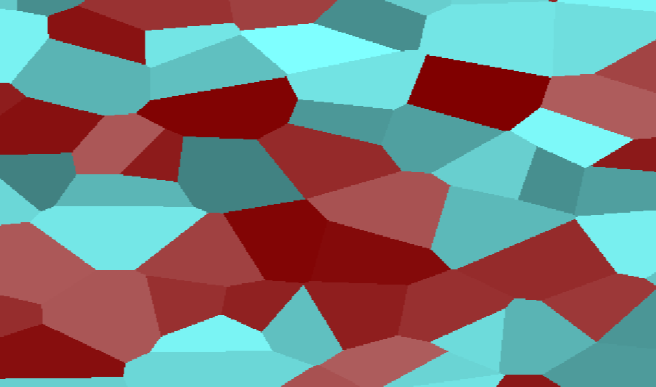

Figure 4.12 Tessellation in Hydra
Code: voronoi(7,0,0).colorama(0.5).scale(0.5).out()
As seen in both the tessellation in Hydra and with the diagram of the different segments of the head, the formation of the scalp is not necessarily rooted in symmetry, some hairstyles account for an asymmetrical style. Like what can be seen in Jay Z hairstyle
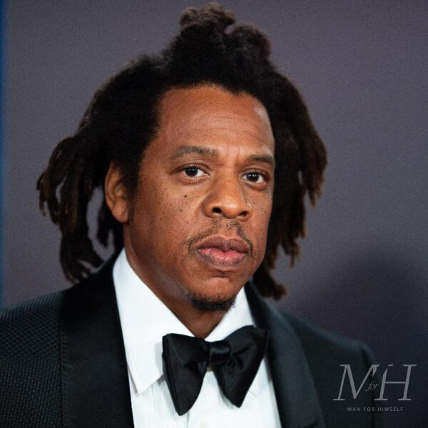
Figure 4.13: Jay Z with an Asymmetrical Hair Style Source: Shawn Carter, Jay-Z arrives at Shrine Auditorium and Expo Hall on October 13, 2021 in Los Angeles, California STEVE GRANITZ/WIREIMAGE Rollingstone.com

HAIR THE CUT (the angles)
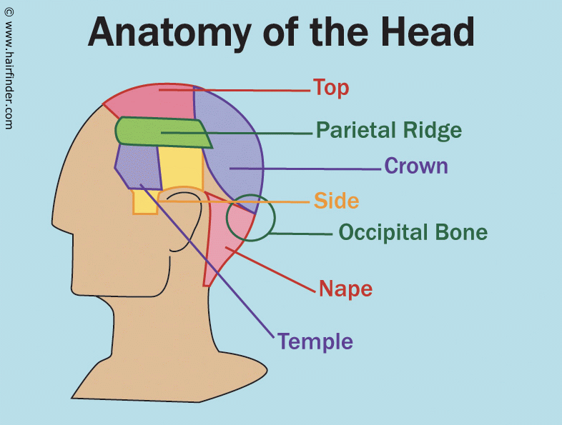
Figure 4.14 - The Regions of the Scalp (Courtesy of https://www.hairfinder.com/info/anatomyhead.htm)

Afro texture hair given its helical shape of hair strands compacted together side by side over the contour of the head creates a three-dimensional shape, that must be treated as such when being cut. The longest part or the hair that creates the illusion of length are those hairs that are beneath the occipital bone. Thus, the nape area is where the length of hair exists appearing long. The “Top” is normally where the hair appears to be the shortest and on tight texture hair needs to be much longer than those hairs at the name to provide a cohesive cut.
During Styling considerations, the crown and nape are angled towards the back and when cutting on curly hair in best practice are cut at 45-degree angle. Creating a surface for the hair above to lay on the hair below. The Parietal Ridge, the temple and Sides are styled towards the side and the top can be directed to either side or a portion can be taken to use as a bang.

5. Transformative Hair Patterns
During the time of slavery, blacks would use their hair as a means of communication. Hairstyles were parted to relay messages. This was a way that slaves could communicate without their master's knowledge, without leaving a trace for their master to understand and without speaking that could be heard by the wrong person as "Enslaved women would braid each other’s hair, incorporating intricate patterns and designs, which not only celebrated their heritage but also served as a way to communicate messages and escape routes for those seeking freedom.” (Dope Black, 2023)

This would make braided hairstyles into topographical reference. Some cornrow patterns mapped out escape routes or signaled where to find water. Given the binding nature of braid it was an excellent place to store seeds, gold nuggets stolen while working mines and even weapons, to ensure survival once they found their way to freedom (Bogaard, 2022).

If we look deep into African history the way one's hair was styled told much about who they were. The most elaborate styles top with head dresses (crowns or other forms of adornment) were reserved for rulers. Priest also had reserved styles. How one's hair was done could also be telling as to one's marital status, socio economic standing, clan membership, and age (HomeTeam History, 2020)

This can be echoed in some artworks that have hair as the medium

- Meshac Gaba - Beninese Artist whose whose work transforms buildings into wigs by way of synthetic hair (Gaba & Perryer, 2007)
- Letitia Ky – Ivorian Activist and Artist - https://www.instagram.com/laetitiaky/
- WeaveTek - https://www.instagram.com/p/CdlDhs6qvVO/?img_index=1

6. CONCLUSION

Right from the root, the math of hair begins
From the helix structure of a strand,
To the helical shape of a coil of curly hair
To the arranging of those hair in stylistic pattern
That can be full of powerful meaning
Deeply rooted in history or an expression of modern fashion.
The pattern of curly is a thing of beauty, complexity, and mathematical marvel.

To complement this research, we have complied a list of resources that we have come across during this research in a github repository. Also accompanying this research paper is a game that can be described as a Guess-Who derivative that deals with the ethnomathematical of black hair alongside the cultural and sociological components that come with it:

GitHub: https://github.com/IllestPreacha/CoilsCurlsMathematicalTapestry

REFERENCES

Bogaard, C. (2022, November 30). African slaves used braids to communicate escape routes in Colombia. Ancient Origins Reconstructing the story of humanity’s past. https://www.ancient-origins.net/weird-facts/braids-0017595
Cleveland Clinic. (2022, August 7). Hair follicle: Function, Structure & Associated Conditions. Cleveland Clinic.https://my.clevelandclinic.org/health/body/23435-hair-follicle
Dope Black (2023, May 22). The history of black people braiding their hair • dope black. . https://dopeblack.org/the-history-of-black-people-braiding-their-hair/#:~:text=Enslaved%20women%20would%20braid%20each,vital%20role%20in%20Black%20communities
Gaba, M., & Perryer, S. (2007). MESCHAC GABA: Tresses + other recent projects. Michael Stevenson.
Gerdes, P. (1994). Reflections on ethnomathematics. For the learning of mathematics, 14(2), 19-22.

GIlmer, G. (1998.). MATHEMATICAL PATTERNS IN AFRICAN AMERICAN HAIRSTYLES. Mathematical patterns in African American hairstyles. http://www.math.buffalo.edu/mad/special/gilmer-gloria_HAIRSTYLES.html

GMMoira. “Unpopular Opinion: The Andre Walker hair typing "system" is useless and should be BANNED from this subreddit” Reddit. Accessed Date (2023, September 10). https://www.reddit.com/r/curlyhair/comments/12hksse/unpopular_opinion_the_andre_walker_hair_typing/.

HomeTeam History. (2020). A History Of African Hairstyles Used As Maps To Escape Slavery. YouTube. Retrieved September 23, 2023, from https://www.youtube.com/watch?v=8agJ_6LVxyk.
McKay, T. (2012, February 3). The mysterious mathematics of curls. NaturallyCurly.com. https://www.naturallycurly.com/curlreading/haircuts/the-mysterious-mathematics-of-curls#

Maynard, K. and Cahnmann-Taylor, M. (2010), Anthropology at the Edge of Words: Where Poetry and Ethnography Meet. Anthropology and Humanism, 35: 2-19. https://doi.org/10.1111/j.1548-1409.2010.01049.x

Michelle K. Gaines, Imani Y. Page, Nolan A. Miller, Benjamin R. Greenvall, Joshua J. Medina, Duncan J. Irschick, Adeline Southard, Alexander E. Ribbe, Gregory M. Grason, and Alfred J. Crosby. Reimagining Hair Science: A New Approach to Classify Curly Hair Phenotypes via New Quantitative Geometric and Structural Mechanical Parameters
Accounts of Chemical Research 2023 56 (11), 1330-1339
DOI: 10.1021/acs.accounts.2c00740

O’Grady, V. J., &amp; O’Grady, V. K. (2017). A designer’s research manual: Succeed in design by knowing your clients + understanding what they really need. Rockport, an imprint of The Quarto Group.

Reyes, A (2021). Curly Hair FUE: My Approach Using Classification of Follicle Curvature and Curl Hair Transplant Forum International Nov 2021, 31 (6) 205-214; DOI: 10.33589/31.6.205

Rowland, Kelly. “Crown”. 2019. Single

The disappointing truth about the most popular hair chart. Mello Hair Solution. (2020, March 8). https://www.mellohair.ca/blogs/news/the-disappointing-truth-about-the-most-popular-hair-chart

